-1- Pass by value.

PHP File: **PHPPassByValueExample1.php**

Argument is called to the function as pass by value.   
Pass by value means a copy of the variable is passed to the function, not the actual variable. Any changes to the variable do not change the original variables value.

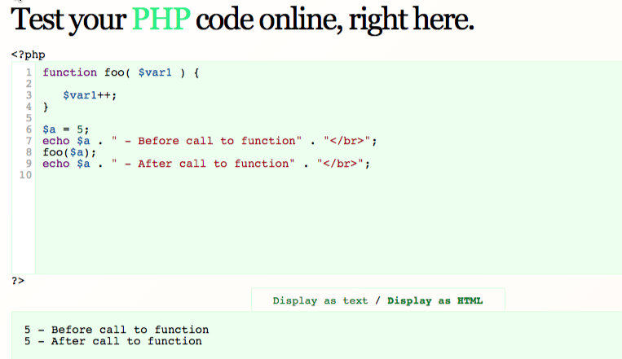

-2- Pass by reference.

PHP File: **PHPPassByReferenceExample1.php**

Argument is called to the function as pass by reference.   
Pass by value means that the address of the variable is passed to the function.  
Any changes to the variable are applied to original variables value.

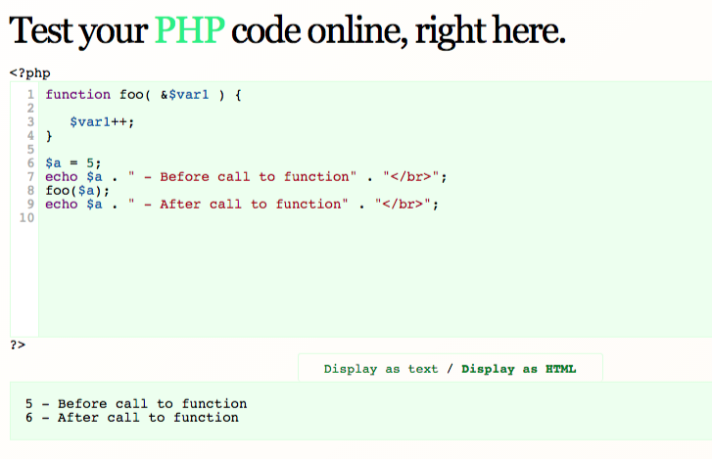

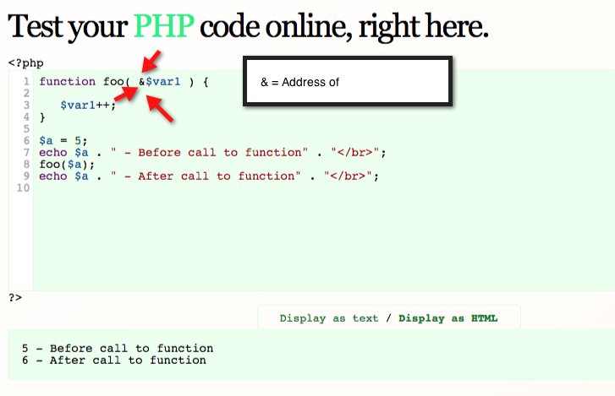

-2- Pass by reference to swap variable values

PHP File: **PHPPassByReferenceSwapaVarsExamples.php**

Three examples of pass by reference to swap variable values.  
  
Swap1- Using Bitwise Xor to do the var swap

http://php.net/manual/en/language.operators.assignment.php  
  
Swap2: http://php.net/manual/en/function.list.php

